ENISA Industry Event for Small and Medium Enterprises

The annual ENISA Industry Event took place today in Brussels, Belgium, and saw the participation of over 70 representatives of the Small and Medium Enterprise (SME) community active in cybersecurity in the EU.

Published on March 01, 2019

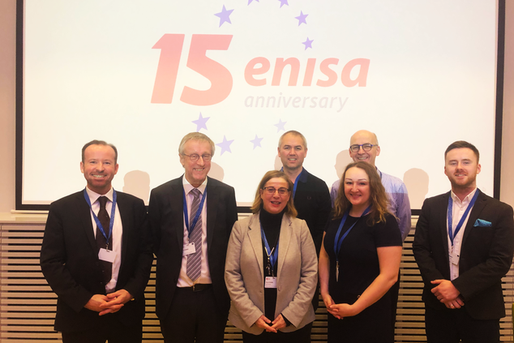

Tagged with

* [NIS Events](https://www.enisa.europa.eu/search?Subject%3Alist=NIS%20Events)

Steve Purser, ENISA Head of Core Operations Department said: “We discussed about ENISA’s continuous efforts to cooperate with and strengthen the EU SME community, touching upon important topics such as the cyber threat intelligence capability framework and maturity model, the technological foresight methodology and also funding of regional cooperation and incubators. We also exchanged views about business opportunities that might arise from the recently launched proposal to set up a cybersecurity competence network and centre. Our Agency is fully committed to supporting the SME community in all these regards.”

The main point of the industry event was the discussion panel on regional cybersecurity collaboration, where representatives from the public and private sector including the European Commission presented their views and shared best practices and successful initiatives.

At the end, Mr. Purser thanked all the participants and invited the community to reach out to ENISA for further support.